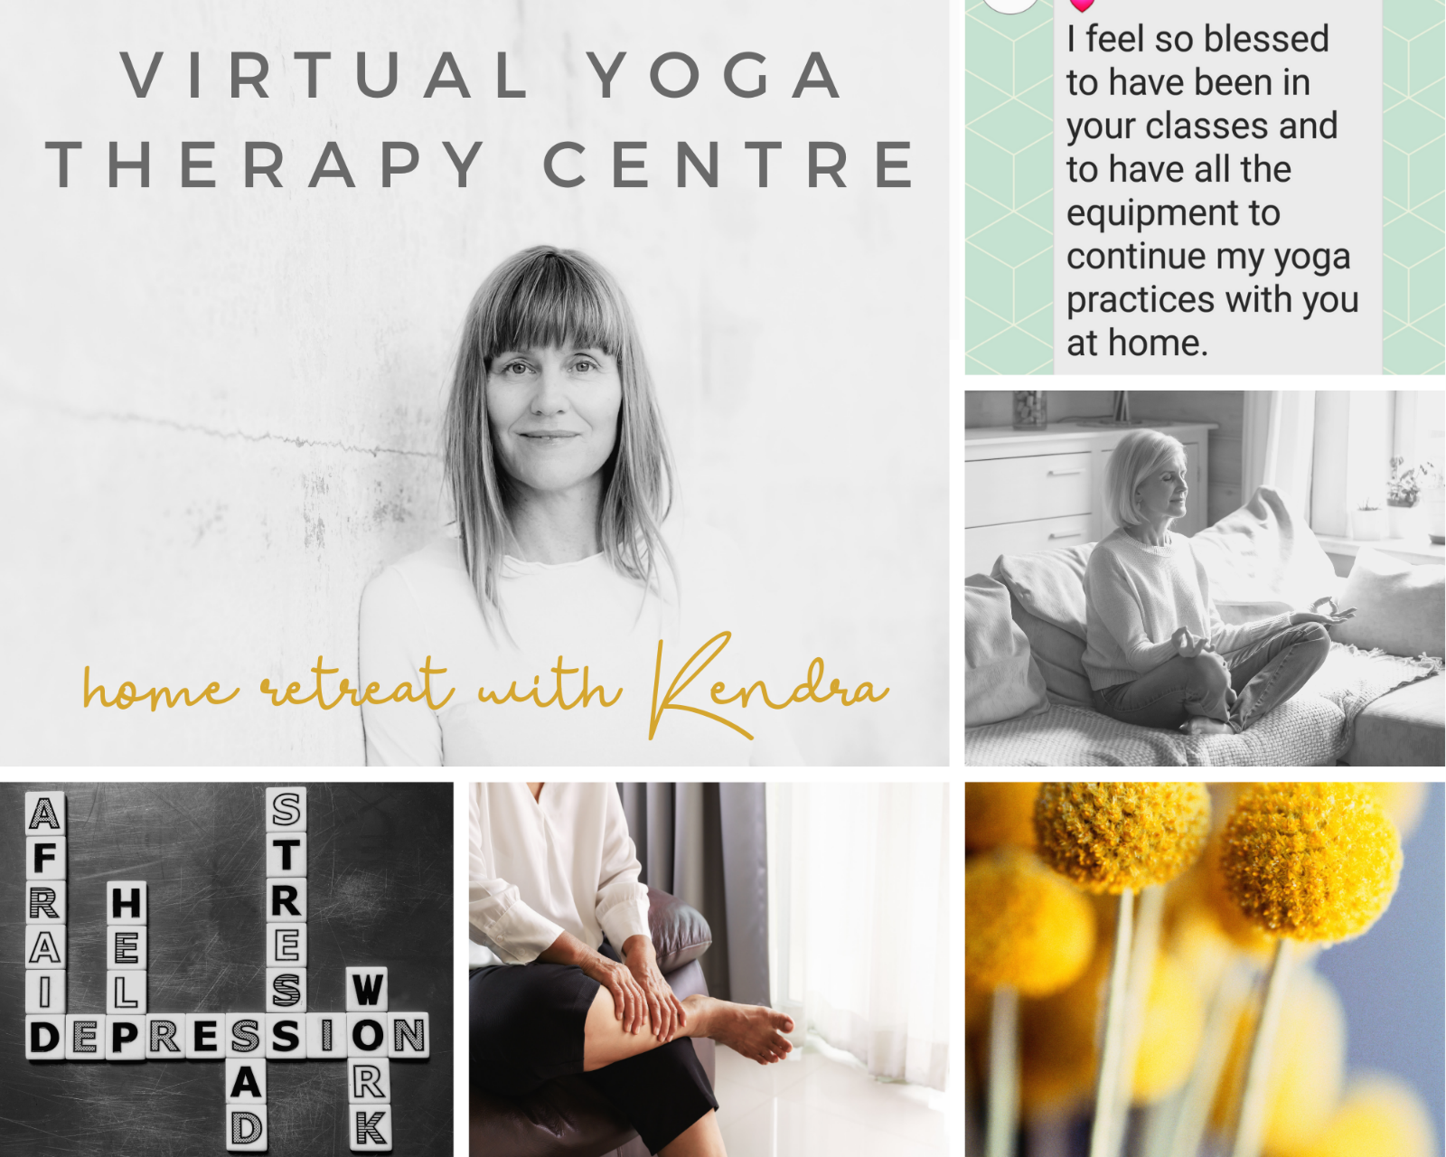
Dear Client
Face to face appointments open
I am happy to announce that Remedial Massage restrictions have been lifted and are now considered an essential service. I am available in my practice in Kambah Tuesday to Thursday and in Braddon Fridays.
**Most importantly I am asking clients with cold and flu symptoms to please reschedule until they have recovered and of course observe 14 days of self-quarantine if they have returned from anywhere overseas.**
Hygiene Precautions
I have procedures in place to manage risks to keep our community healthy and safe.
I will continue to respond to the current global health challenge, and I am taking regular advice from my association the Australian Traditional Medicine Society and the Australian Department of Health.
I have in place procedures to protect you and the clinic.
These include:
* regularly cleaning all surfaces including door knobs, frequently touched equipment and bench tops
* washing our hands with soap and water regularly
* Having hand sanitiser available for clients
* Linen is changed on massage tables after each client and any hard surfaces are cleaned between clients. 15 minutes will be placed between appointments.
What you need to do during an appointment
*consider bringing your own sheet and towel to use
*use the sanitiser upon entry

Even though face to face yoga classes are returning, you have the option to remain at home in the comfort of your home to live stream your class. This is particularly beneficial if this helps you feel safe and nurtured, and you are confident to receive the teachings remotely.

I have recently opened a virtual Yoga Therapy and Meditation Centre offering online trauma informed personal and group development sessions to help you manage mental health challenges and ensure you can keep working productively and engaging in things you enjoy.
It is the perfect time to develop a daily home practice and keep a check on your stress levels.

Online Zoom telehealth appointments
Being in the comfort of your own home for a session is new to most of us, but this is something I have been delivering for some time. It’s a simple process of receiving a link to a Zoom meeting to connect into the virtual world.
Online live streaming courses and classes
Regular daily group yoga therapy classes and private 1 :1 sessions are offered.
Investment choices
- $25 per class
- $40 per class (you support someone else to attend)
- Donate what you can or pay it forward
- $100 per hour private yoga therapy
- Group courses available every 6 weeks

Retreat Membership coming soon
If you prefer to practice in your own time and have access to weekly pre-recorded classes each week, courses like Zen Recovery, Sleep Surrender and much more, then consider joining Kendra’s Retreat Membership coming soon.

I will continue to respond to the current global health challenge, and I am taking regular advice from the WHO and the Australian Department of Health.
Please contact me anytime on 0417423804 for further information.

Stay in touch.

Kendra

